**UML Activity Diagram**

The activity diagram is a UML diagram for modelling the processes in a situation. A process is a sequence of steps carried out with a particular goal. An activity diagram models a process by showing the flow of activities in a situation.

Activity diagrams are used to model many different types of processes:

* the flow of a software process or a part of a software process
* the flow of control in a function or method in a computer program
* the flow of control in an operation in a UML class diagram
* the sequence of activities in a business process or part of a business process
* the sequence of activities in a single use case in a UML use case diagram
* the sequence of activities in a series of use cases in a UML use case diagram.

The basic notation for an activity diagram is shown in Figure 1 (note that ‘pseudo’ indicates that this is not the true start and end of a whole process but just a small part of a larger process).

Activity diagrams can be shared with the end-user but still require some training to understand the notation.

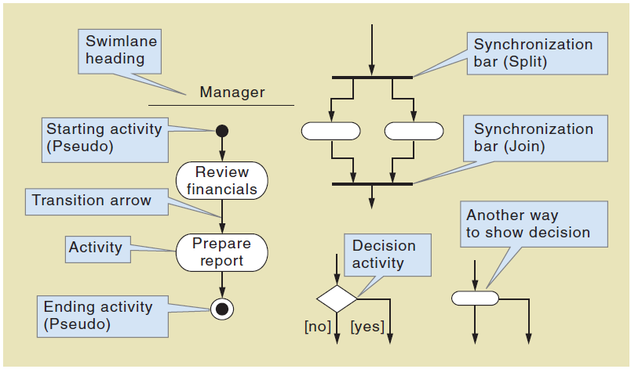

Figure 1 Basic activity diagram symbols

Figure 2 is an example of an activity diagram showing the flow of activities when an editor receives a book proposal from an author.

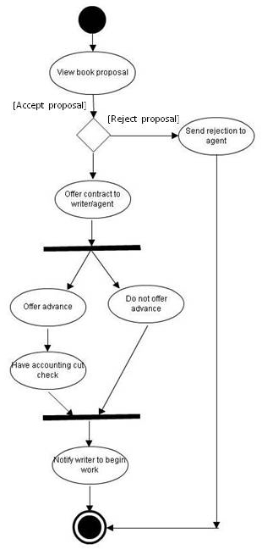

*Figure 2 An activity diagram showing the process of an editor receiving a book proposal from an author*

## Preparation

Listen to these introductory lecture videos on how to draw an activity diagram (they take about 5 minutes each)

* Basic model notation
  + <https://www.youtube.com/watch?v=paWIY7EPWpE>
* Parallel paths
  + <https://www.youtube.com/watch?v=f5oSFwpl2KI>
* Swim lanes
  + <https://www.youtube.com/watch?v=bYB7Dcbr1tc>

## What to do

Consider this scenario.

*A city veterinary practice that treats small animals such as cats, dogs, and guinea pigs needs a new computer system. The analyst has interviewed a veterinarian and a vet nurse who also acts as the office administrator. The analyst has recorded the main activities that take place for a non-emergency visit to the vet. An animal owner will usually either call the clinic or use the website to book an appointment. The owner either enters their information on the website or provides the information on the phone including their own details, animal details, and the reason for the visit (i.e. the main symptoms or known illness/issue). If an animal and its owner arrive at the clinic without an appointment, the administrator enters the necessary details, if this is the first visit. If the owner and animal details are already on the system then the administrator looks up the animal information and records the primary reason for the visit. Once the owner and animal arrive for their appointment the vet examines the animal and prescribes a solution. The administrator accepts payment and makes a return appointment if necessary.*

**Online tutorial**

1. Sketch the model on paper.
2. Draw the model using Visual Paradigm. Use two swim lanes if VP allows for this (administrator and vet).
3. Discuss the diagram as a class or in small groups to identify errors, omissions, interpretations of the scenario, or missing information.
4. Place the Visual Paradigm model in a word document (use the Export function or select the whole diagram and copy it into your document). Add an explanation of the model (3 sentences or less), and add a caption to the model (just like the captions for the figures in this tutorial worksheet).
5. Upload your document with a filename containing your surname, and first name to the Moodle forum for this tutorial.

**On campus tutorial**

1. Sketch the model on paper.
2. Form groups and compare your models.
3. Create one best version that combines all of the models.
4. Draw the model on the whiteboard.
5. Discuss each group’s model to identify the most appropriate model.
6. Individually, draw the most appropriate model using Visual Paradigm. Use two swim lanes if VP allows for this (administrator and vet).
7. Place the Visual Paradigm model in a word document (use the Export function or select the whole diagram and copy it into your document). Add an explanation of the model (3 sentences or less), and add a caption to the model (just like the captions for the figures in this tutorial worksheet).
8. Upload your document with a filename containing your surname, and first name to the Moodle forum for this tutorial.