**User Interface Design**

There are many different principles and guidelines for user interface design but Schneiderman’s principles for designing user interfaces are well known and used by the IT industry (Shneiderman et al., 2016). This traditional set of guidelines is called the 8 golden rules of interface design (see Figure 1)

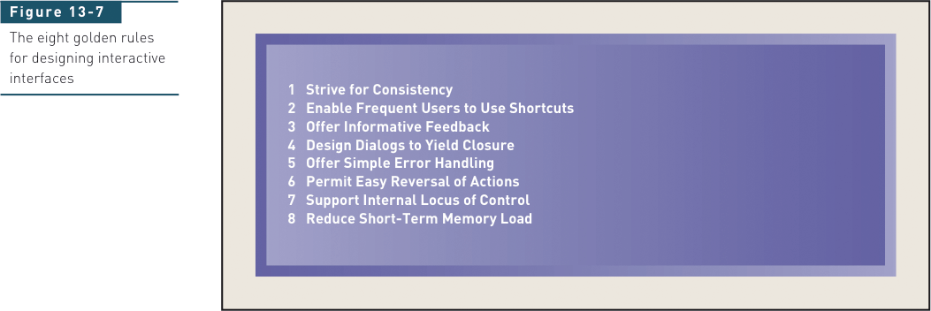

Figure 1 From Satzinger, Jackson and Burd (2015).

The eight golden rules are defined as follows.

1. **Strive for consistency.**Consistent sequences of actions should be required in similar situations; identical terminology should be used in prompts, menus, and help screens; and consistent commands should be employed throughout.
2. **Enable frequent users to use shortcuts.**As the frequency of use increases, so do the user's desires to reduce the number of interactions and to increase the pace of interaction. Abbreviations, function keys, hidden commands, and macro facilities are very helpful to an expert user.
3. **Offer informative feedback.**For every operator action, there should be some system feedback. For frequent and minor actions, the response can be modest, while for infrequent and major actions, the response should be more substantial.
4. **Design dialog to yield closure.**Sequences of actions should be organized into groups with a beginning, middle, and end. The informative feedback at the completion of a group of actions gives the operators the satisfaction of accomplishment, a sense of relief, the signal to drop contingency plans and options from their minds, and an indication that the way is clear to prepare for the next group of actions.
5. **Offer simple error handling.**As much as possible, design the system so the user cannot make a serious error. If an error is made, the system should be able to detect the error and offer simple, comprehensible mechanisms for handling the error.
6. **Permit easy reversal of actions.**This feature relieves anxiety since the user knows that errors can be undone; it thus encourages exploration of unfamiliar options. The units of reversibility may be a single action, a data entry, or a complete group of actions.
7. **Support internal locus of control.**Experienced operators strongly desire the sense that they are in charge of the system and that the system responds to their actions. Design the system to make users the initiators of actions rather than the responders.
8. **Reduce short-term memory load.**The limitation of human information processing in short-term memory requires that displays be kept simple, multiple page displays be consolidated, window-motion frequency be reduced, and sufficient training time be allotted for codes, mnemonics, and sequences of actions.

# Tutorial overview

Apply the 8 golden rules of user interface design to analyse a commonly used e-commerce[1] site (e.g., Harvey Normans, Amazon, Trademe, Vodafone).

**Preparation**

Read this website that provides examples of each of the eight golden rules (this link is also shown on the Moodle Resources tab):

<https://webdesign.tutsplus.com/articles/8-golden-rules-for-better-interface-design--cms-30886>

# What to do

1. Choose an appropriate e-commerce site that is published by a New Zealand or international company. This is the site you will analyse.
2. For your chosen site, analyse either the website on the computer or the equivalent version for the mobile phone.
3. On your chosen site, find an example of each of the eight golden rules used or broken.
4. Make your analysis notes into a word document. Include the name of the company, the purpose of the website, and the site URL. Explain how the rule is implemented or not, on the website and use screenshots as evidence of each rule (used or broken) – if possible.
5. Upload the Word document to the Moodle forum for this tutorial. Name the file ‘Tutorial X YourSurname’.

# References

Shneiderman, B., Plaisant, C., Cohen, M., Jacobs, S., Elmqvist, N., & Diakopoulos, N. (2016). *Designing the User Interface: Strategies for Effective Human-Computer Interaction*. Pearson.

1. E-commerce is the buying and selling of goods and services over the Internet. E-commerce is conducted over computers, tablets, smartphones, and other smart devices. Ecommerce operates in four market segments, including business-to-business, business-to-consumer, consumer-to-consumer, and consumer-to-business. Source: <https://www.investopedia.com/terms/e/ecommerce.asp>