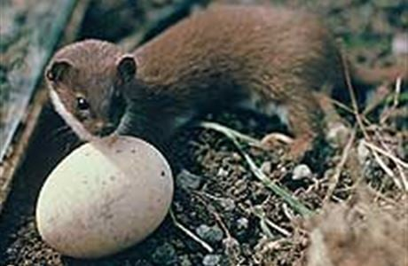Bachelor of Information Technology

**Systems Analysis and Design IT6501**

**Assignment 2 Part A**

**Due date and time** Friday 16 Sept 9 pm

## Submission details

Upload your document into the Assignment 2 Part A Dropbox in Moodle.

## Extensions

Extensions of time will be granted for students who have an acceptable documented reason for not completing the assessment by the specified due date.

## Terms

An attempt to pass this assessment must be made in order that the student will be eligible to sit the final exam for this module.

**Grading**

This assignment is worth 15% of the total module.

The assignment is marked out of 15.

**Deliverables**

Produce a system requirements report. This report is for an app for a smartphone to support the needs of the organisation described in the case study – PredatorFree T222. The following information must be included in the report:

* 1. An executive summary explaining the contents of the report.
  2. A statement of scope that explains the purpose of the app, who will benefit from the app, and the main business requirements for the new system.
  3. A use-case diagram for the system.
  4. Full functional requirements for the system. Provide the requirements in a numbered list.
  5. Full non-functional requirements for the system. Provide the requirements in a numbered list.
  6. A list of system stakeholders stating their interest in the system. Put this analysis in a table.
  7. A domain class diagram for the system including classes, attributes, associations, and multiplicity. Show inheritance hierarchies if necessary.
  8. A prototype sketch of the main page of the new app. Draw this by hand in pen or dark pencil. Photograph the sketch and insert the photograph into your report as a figure.

**Notes**

* The functional and non-functional requirements of the server network and its administration systems are outside the scope of this assignment.
* The report must be to business standard (appropriate fonts and font size, a bit like this assignment description). Each section must have a brief explanation of the purpose of the section. Each table and figure (model or diagram) in the report must include a brief description of its purpose and a reference to the figure in the text.
* All figures and tables should have a numbered caption (in MS Word, click on the table or figure and use References | Insert caption.
* This assignment is carried out individually, not in groups.
* Produce all UML models using Visual Paradigm. You are strongly advised to create initial sketches on paper before proceeding to use the diagramming tool.

**Marking Schedule**

|  |  |  |
| --- | --- | --- |
|  | **Requirements** |  |
| 1 | Executive summary |  |
| 2 | Scope statement |  |
| 3 | Use case model |  |
| 4 | Functional requirements |  |
| 5 | Non-functional requirements |  |
| 6 | Stakeholders and interest |  |
| 7 | Domain class model |  |
| 8 | Prototype sketch |  |
|  |  |  |
|  | **Quality evaluation requirements** | **Grading** |
| * All requirements are present in the report. * The introductory sections are accurate and clearly written. * The report is written clearly and describes each section appropriately in a sentence or two. The report must be to business standard. * Models show correct notation and naming conventions and have a title. * Consistency between models in terms of names and relationships. * Consistency between models and requirements. * Requirements are listed in full, both functional and non-functional, and are consistent with the models. * Modelling tool is used correctly. * Each table and figure (model or diagram) in the report includes a brief description of its purpose and a reference to the figure in the text. * Quality of document is excellent and includes: page numbers, correct English spelling and grammar, appropriate fonts, layout, and headings. Figures and tables have appropriate captions. | | **13-15 marks**  All requirements are present in the report.  All quality evaluation requirements are met in full with very minor errors.  **10-12 marks**  Almost all requirements are present in the report. Quality evaluation requirements met but with some errors and omissions or one major omission.  **7-9 marks**  Some requirements are present in the report. Quality evaluation requirements not met in full. There are multiple errors and omissions or more than one major omission.  **4-6 marks**  The sections of the model are not explained properly and the models are incorrect and or inconsistent. There are multiple errors and omissions.  **0-3 marks**  Requirements not met. Quality evaluation requirements not met. The report has multiple errors and omissions. |
| Total | | 15 |