## IT5507 Fundamentals of Data Science

**Lab 6 - Data Design and ERD**

**Review Questions**

1. Explain the main differences between a file processing system and a database system.
2. What is a DBMS? Briefly describe the components of a DBMS.
3. Describe a primary key, candidate key, secondary key, foreign key, and common field.
4. What are entity-relationship diagrams and how are they used? What symbol is used to represent an entity in an ERD? What symbol is used for a relationship? What is cardinality, and what symbols do you use in the crow’s foot notation method?
5. What are data warehousing and data mining? Are the terms related?
6. Draw ERD Diagram for the following scenario:  
   (first, you need to identify the entities and then relationships)

In a university, a Student enrolls in Courses. A student must be assigned to at least one or more Courses. Each course is taught by a single Professor. To maintain instruction quality, a Professor can deliver only one course.

1. Draw an ERD for the following description:

*A department controls a number of projects, each of which has a unique name, a unique number, and a single location.*

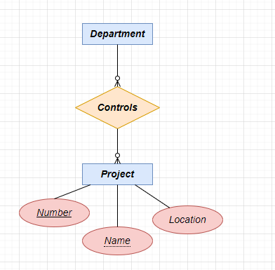

1. Draw an ERD for the following description:

*Each department has a unique name, a unique number, and a particular employee who manages the department. We keep track of the start date when that employee*

*began managing the department. A department may have several locations.*

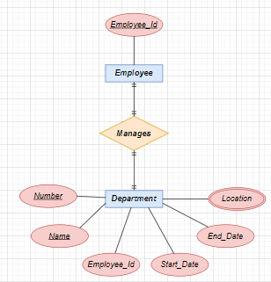

1. Draw an ERD for the following description:

*We store each employee’s name (first, last, Middle), Social Security number (SSN), street address, salary, sex (gender), and birth date. An employee is assigned to one department but may work on several projects, which are not necessarily controlled by the same department. We keep track of the current number of hours per week that an employee works on each project. We also keep track of the direct supervisor of each employee (who is another employee).*

1. Re-draw below ERD using Visual Paradigm Crow’s foot notation and based on following business rules. A salesperson may manage many other salespeople. A salesperson is managed by only one salesperson. A salesperson can be an agent for many customers. A customer is managed by one salesperson. A customer can place many orders. An order can be placed by one customer. An order lists many inventory items. An inventory item may be listed on many orders. An inventory item is assembled from many parts. A part may be assembled into many inventory items. Many employees assemble an inventory item from many parts. A supplier supplies many parts. A part may be supplied by many suppliers.

