**IT5507 – Fundamentals of Data Science – Lab 7.1**

**"Artificial Intelligence Trends and Insights: Global Data exploration"**

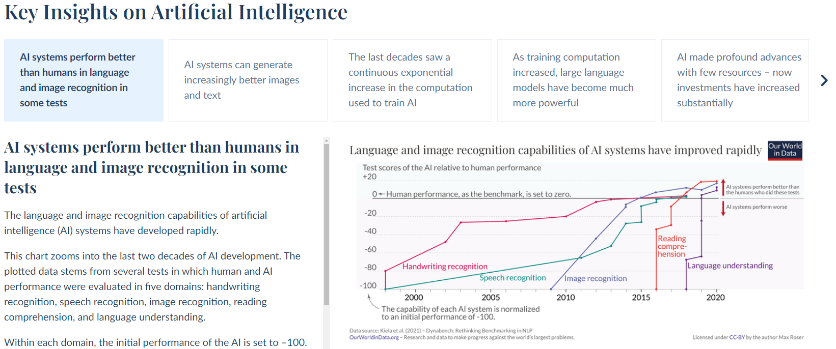

Here is a step-by-step guide to engage with the Our World in Data website's interactive chart on Artificial Intelligence example:

1. **Go to the Our World in Data website**: Visit the Our World in Data website using the following link: [Our World in Data - Artificial Intelligence](https://ourworldindata.org/artificial-intelligence#introduction)

<https://ourworldindata.org/artificial-intelligence#introduction>

1. **What are the three important Key insights on Artificial intelligence?**
2. **Observe the trend of global AI adoption**: Look at the interactive chart on the website. Observe the trend of global Artificial Intelligence (AI) adoption over time. Determine whether it is increasing, decreasing, or remaining stable. Write down your observations.
3. **Explore differences in AI adoption between regions**: Use the interactive features of the chart to explore variations in AI adoption across different regions of the world. Compare AI adoption rates between continents or specific countries. Take note of any significant differences you observe.
4. **Identify periods of rapid growth or decline in AI adoption**: Examine the chart closely to identify any periods of rapid growth or decline in AI adoption. Speculate on the potential reasons behind these changes. Consider factors such as technological advancements, regulatory frameworks, and economic conditions.
5. **Analyze the impact of AI adoption on various sectors**: Reflect on the impact of AI adoption on different sectors such as healthcare, education, finance, and transportation. Discuss how AI technologies are transforming these sectors and improving efficiency, productivity, and innovation.
6. **Discuss the challenges and ethical considerations of AI adoption**: Consider the challenges and ethical considerations associated with the widespread adoption of AI technologies. Discuss issues such as job displacement, algorithmic bias, privacy concerns, and the need for responsible AI development and governance.
7. **Look for** **“Chess ability of the best computers” from the charts.**What are some notable milestones in computer chess ability depicted on the chart, and what might have led to these advancements?   
   How has computer chess ability evolved, and what implications does this trend have for the field of artificial intelligence and gaming technology?