IT5507 – Fundamentals of Data Science – Lab 12

**Introduction to Creating a Database, table, design**

**Exercise 1)**

**Step 1:** Create a new database to hold your Christmas shopping list ideas, called **Xmas list.**

In this database, create and populate a table called **Person** to hold the people for whom you are buying presents:

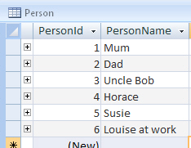

*Here the PersonID field will be the primary key*

**Step 2:** Now create a table of all the places from which you typically buy presents and call it **Shop** - here is what it might look like:

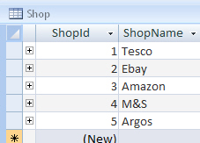  
*Feel free to add your own favourites!*

**Step 3:** Create a third table that allows you to enter present ideas name it the **Idea** table:

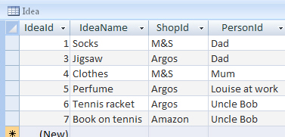  
*Hopefully your present ideas are more imaginative than this*

**Step 4:** Close down all of the tables that you have created, and enforce referential integrity for the relationships:

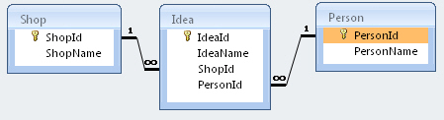

*This is what your relationship diagram should look like*

Close down your database!

**Exercise 2)**

**Step 1:** Create a new database called Recipes.

Create a new table called **Area** to hold the different supermarket areas from which you can buy ingredients. When you have defined the fields, enter data as shown below:

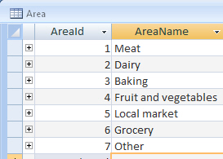  
*Your table should contain two fields, as shown above*

**Step 2:** Close this table down, then create another table called **Recipe** to hold your favourite recipes (if you haven't got any, make them up!). Here is what this might look like:

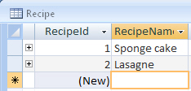  
*Here we will add the ingredients for two recipes, but feel free to choose different ones*

**Step 3:** Finally, create and populate a table named **Ingredient** to hold the ingredients that you need to buy - this might look like this:

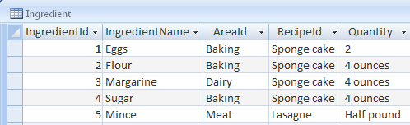  
*Note that in this case, Quantity will be a text field*

**Step 4:** Then, apply referential integrity to your relationships:

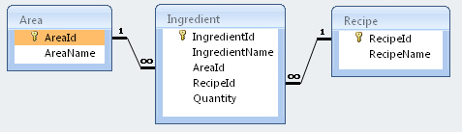  
*This is what the final diagram should look like*

Close your database down when you have finished.

**Exercise 3)**

**Step 1:** The aim of this exercise is to create a table to hold the countries in which films can be made. In an Access database, create a new table:

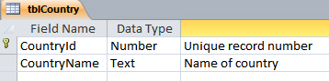  
*Create this table using the notes below.*

The table should have two fields:

1. an integer field called **CountryId** to hold the country number; and
2. a text field called **CountryName** to hold the country name.

**Step 2:** You should make the integer field the primary key. Now append all of the records from the following table into your created table:

|  |  |
| --- | --- |
| CountryID | CountryName |
| 48 | China |
| 79 | France |
| 118 | Japan |
| 167 | New Zealand |
| 240 | United Kingdom |
| 241 | United States |
| 257 | Germany |
| 258 | Russia |

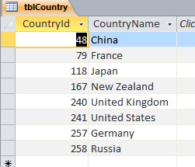  
*What your final table should look like - apologies for the Western slant to the data!*

Close this table down.

*You can grab the template answer of the file on Day 12 to see the answers to these exercises, although please remember this is for you to check and confirm your attempted exercise only.*