# Queries

Previously, you have used a filter to view the information contained in your tables. Another approach that is far more powerful for extracting information from a table or more than one table is to use a query. When you run a query the results look like another table. A query can be saved and used repeatedly with the most up-to-date data from your tables.

There are several types of query. However, for the purpose of this course, we will just be using select queries.

## Create a query using the Query Wizard

1. On the ribbon, select the ***Create*** tab
2. Click on the ***Query Wizard*** button

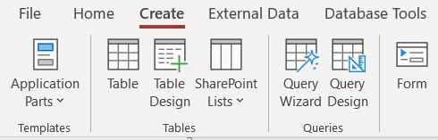

The *New Query* dialog box will appear

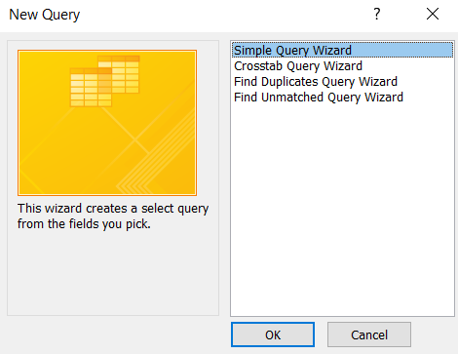

1. Highlight the top option *Simple Query Wizard* then click ***OK***. The *Simple Query Wizard* will appear.

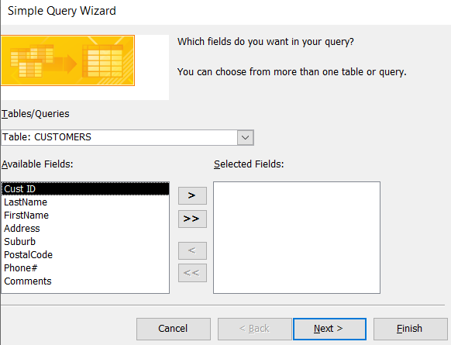

1. *Tables/Queries* Field: Ensure **Table: CUSTOMERS** is selected
2. Move the following *Available Fields* across to the *Selected Fields* box

**Last Name, First Name, Phone #**

**Remember**: To move the above fields one-by-one, select each field in the *Available Fields* box and click the ScreenHunter_10 arrow button.

1. Click ***Next***
2. In the box that says ‘*What title do you want for your query*?’, name the query **Customers’ phone numbers**

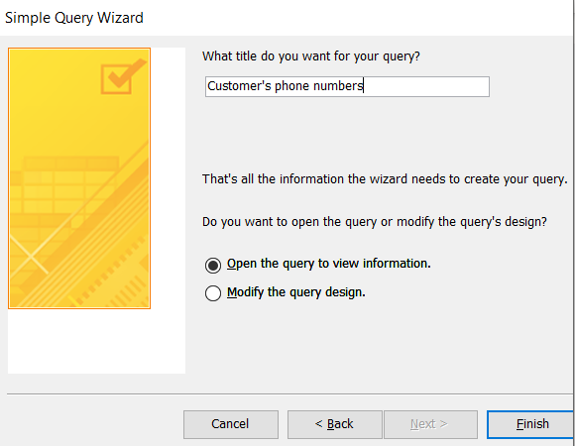

1. Click ***Finish***

The results of the query will now appear

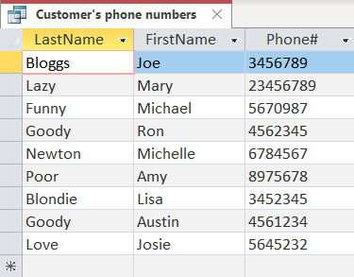

1. Close the query either by right-clicking on the name tab and selecting ***Close***, or click the ***x***in the top right corner.

## Create a query in Query Design View

The wizard approach is a quick and simple method for producing a query but lacks the control and sophistication that is needed for many queries. Next use the *Query Design View* window.

1. On the ribbon, select the **Create** tab
2. Click on the ***Query Design*** button

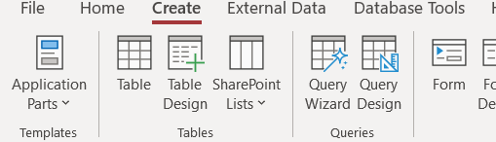

The *Show Tables* dialog box will appear. Ensure the **Tables** tab is selected.

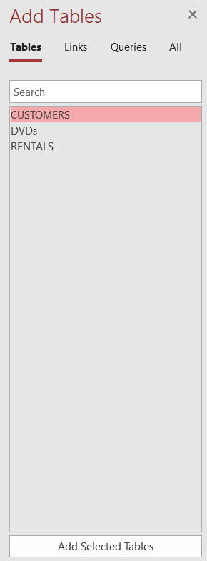

1. Highlight **CUSTOMERS** and click the ***Add*** button to add the table to the query window
2. Click ***Close*** to remove the Show Table dialog box

The Select Query window now appears. The top half of the window (*Query Pane*) contains the Field list, a graphical representation of the **CUSTOMERS** table and its fields. The bottom half (*Query Design Grid*) contains space for the criteria that are used to specify the query.

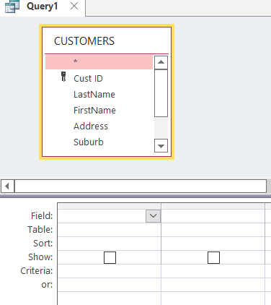

**Tip:** In the *Query pane*, the table box can be increased in size. Drag down the bottom of the box so all the fields are displayed.

1. Select the **Cust ID** field (in the *Query Pane*) and drag it down into the **Field** row in the first column of the *Design grid*, then release the mouse button. (You can also double click the required Field name and it will transfer to the field row of the *design grid*.)
2. In the same way, select and drag each of the other fields down, each to a separate column
3. 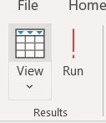Now run the query. Click on the ***Run***button at the left end of the ribbon.

1. Click the ***Save*** button on the Quick Access toolbar **or** right-click on the **Query1** tab and select ***Save***
2. In the Query Name box, type *Customer Query*, then click ***OK***

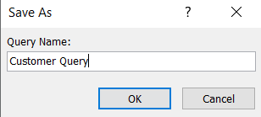

## Sorting data using queries

Notice that the records are stored in **Cust ID** order, the order in which they were originally entered. This is not always a useful way of viewing the data. Reorder the records in order of the customer’s last name

1. 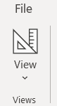On the ribbon, ensure that the **Home** tab is selected
2. Click on the ***View*** button at the left end of the ribbon and select *Design View*

1. In the design grid, click in the ***Sort*** row of the **Last Name** column and a drop down box will appear.
2. Select *Ascending.*

We don’t really need to see the **Cust ID** field so we will make it invisible.

1. Remove the tick below the **Cust ID** column.

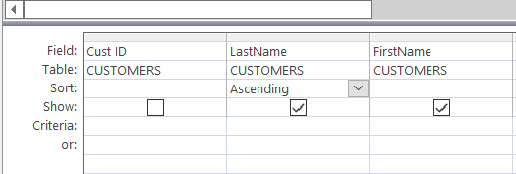

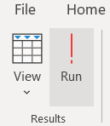

1. Click on the **View** button at the left end of the ribbon.

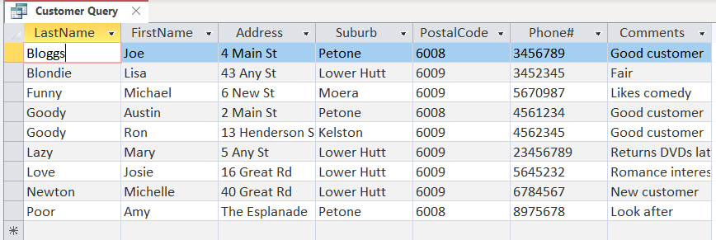The resulting query should now look like this

1. Right click on the **Customer Query** tab and select ***Close****.* If you are prompted to save the changes to the design of the query, click ***Yes****.*

## 

## Using criteria

The next query displays records that have a **Suburb** value of Petone, in other words, all the customers who have addresses in Petone. The criteria field is used to restrict the display according to the rules specified by the user.

1. Create a new query in *design view* using the following fields from the **CUSTOMERS** table

**Last Name, First Name, Suburb, Phone #**

1. Ensure the **Create** tab is selected on the ribbon and click the ***Query Design*** button.
2. Drag down each of the four fields one by one from the *query pane* to the *design grid*. (Or double click the desired fields.)
3. **Sort** row, **Last Name** column: select **Ascending**
4. **Criteria** row, **Suburb** column: type **Petone** and press the Enter key. **Note:** Double quotes will appear around the name of the suburb.

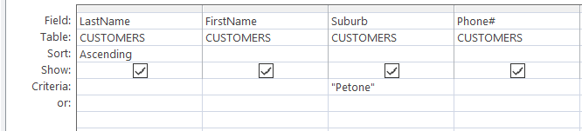The design grid should now look like this

1. Save query as **Customer Details for Petone**
2. Run the query. The resulting query should look like this:

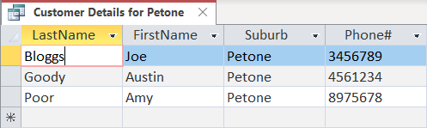

1. Right click on the name of the query and select ***Close*** to close the query.

## Using two criteria

You can also select customers who have an address in Petone or Moera. To create a query where you want one criteria or another matched, you use the **or:** row.

1. 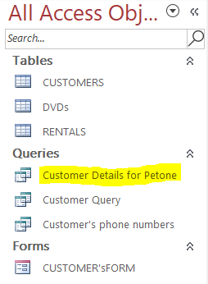Open the **Customer Details for Petone** query again by double clicking it in the Navigation pane
2. Select *Design View* by clicking on the ***View*** button at the left end of the ribbon.
3. In the Design grid, type **Moera** in the **or** row of the **Suburb** column, then press the Enter key

The design grid should now look like this

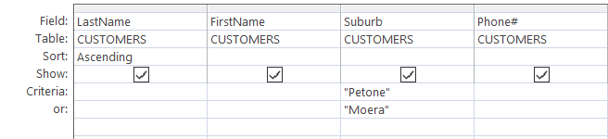

1. 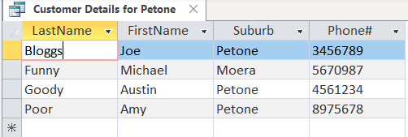Run the query. The resulting query should look like this:

However, the name of the query is now incorrect. Before you can rename a query, you must close it.

1. Close the query by right clicking on its name tab and selecting ***Close***
2. You will be prompted whether or not you want to save the changes. Select ***Yes***

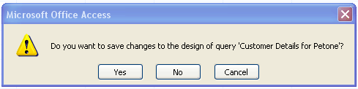

1. Right click the query in the Navigation pane and select **Rename**
2. Rename the query **Customer Details for Petone and Moera**
3. Open the query again by double clicking its icon in the Navigation pane

The name of the query will now be changed

1. Close the query

## 

## Parameter Queries

This type of query requests information from the user about what is going to be included in the criteria row. For example, rather than creating numerous queries to display the data for each of the different Suburb records, a Parameter Query would request which suburb a user wants displayed.

Create a new query in *design view* using the following fields from the **CUSTOMERS** table

**Last Name, First Name, Address, Suburb**

1. To do this, ensure the **Create** tab is selected on the ribbon and click the **Query Design** button.
2. Add the **CUSTOMERS** table to the query pane
3. Drag down each of the four fields one by one from the query pane to the design grid.
4. **Sort** row, **Last Name** column: select **Ascending**
5. **Criteria** row, **Suburb** column: type *[Which suburb?]*– (Include the square brackets.)

The design grid should now look like this

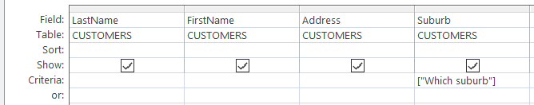

1. Run the query
2. Save query as **Parameter query to choose suburb**
3. 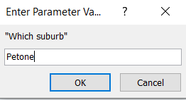Run the query. A dialog box will appear asking you to input which suburb you want.  
   Type **Petone**
4. Click **OK**. The data for Petone will appear

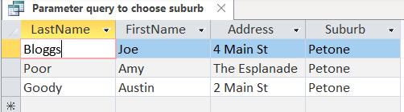

1. Close the query

## Queries involving more than one table

Often when using a Select Query you would like to include related information from more than one table. DVD Rentals needs to know what DVDs each person hired and on what dates. The resulting information is to be sorted into date order.

In this case we will use all three tables at the same time.

1. 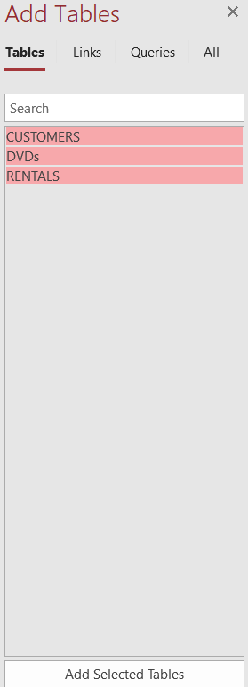Create a new query in *design view*
2. Add all three tables
3. To do this - highlight all the tables in the *Show Table dialog box* by holding down the shift key while you click each one.
4. Then click the ***Add***button. All the tables will be added to the design grid.
5. Move the tables around so that the **RENTALS** table is in the middle and a little bit below the other two tables.
6. Drag **Last Name** and **First Name** from the **CUSTOMERS** table to the design grid
7. Drag the **Title** field from the **DVDs** table to the design grid
8. Drag the **Date Hired** field from the **RENTALS** table to the design grid
9. **Sort** row: **Date Hired** column - select **Ascending**
10. Save the query as **Who hired which DVDs and when?**

*Design view* should now look like this

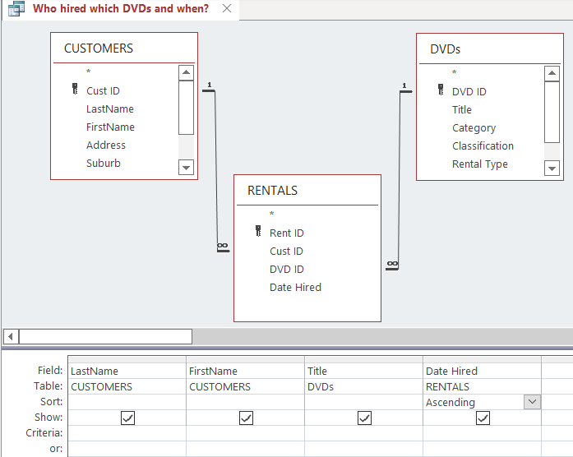

1. Run the query.

Each DVD hire will be displayed in date order with name of DVD and person who hired it.

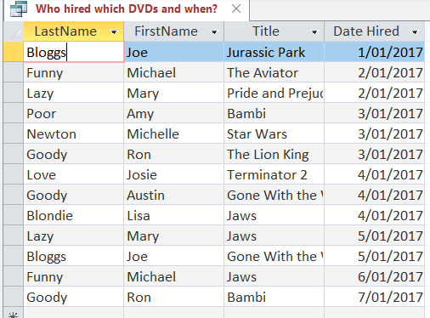

1. Close the query

## Totalling queries

Another query that DVD Rentals would find useful is one that would give the total amount spent by each customer. This would be useful in identifying good customers who can be offered special deals in the future.

1. Create a new query in *design view*
2. Add all three tables to the query pane
3. Drag **Last Name** and **First Name** from the **CUSTOMERS** table to the Design grid
4. Drag the **Hire Charge** field from the **DVDs** table to the Design grid
5. **Sort** row, **Hire Charge** column: select **Descending**
6. On the ribbon, ensure that the **Design** tab is selected
7. Click on the **Totals** button. The Totals row will be added to the design grid

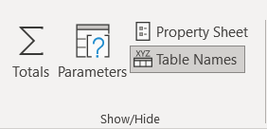

1. Click in the **Totals** row in the **Hire Charge** column and select **Sum** from the drop-down box.
2. Save the query as **How much did each customer spend?**

*Design View* should now look like this.

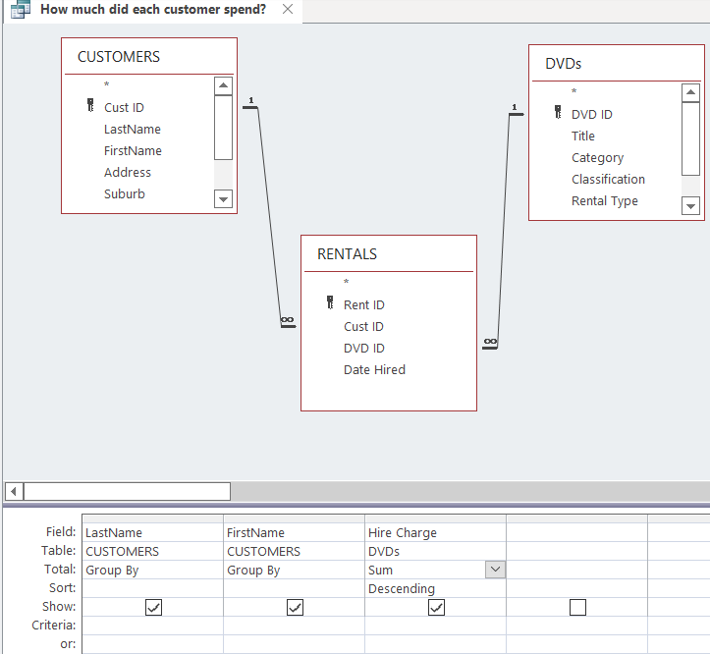

1. Run the query. The result should be as below

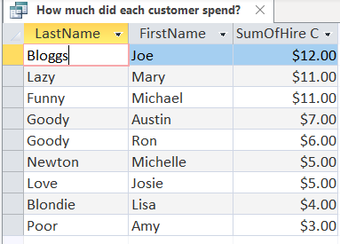

1. Close the query

## Other Query Types

There are other types of queries called Action Queries. Action Queries can be:

* **Delete** queries that allow specifically selected records to be deleted and are useful when large numbers of records with a common pattern are being deleted.
* **Update** queries that allow editing of specifically selected records and are useful when large numbers of records with a common pattern are edited.
* **Append** queries that allow specifically selected records to be added to a table and are useful when large numbers of records with a common pattern are added.
* **Make-Table** queries create a new table from all or part of the data in one or more tables. Make-table queries are helpful for exporting tables, creating data access pages that display data from a specified point in time, and making a backup copy of a table.