
IT5507 – Fundamentals of Data Science – Lab 14

Introduction to Forms and Reports in a MS Access database

Exercise 1)
Step 1: Before you can do this exercise, you'll need to download the file from the Moodle called “Pets Database”

Create a new basic form based on the Pet table, which resembles the example below:

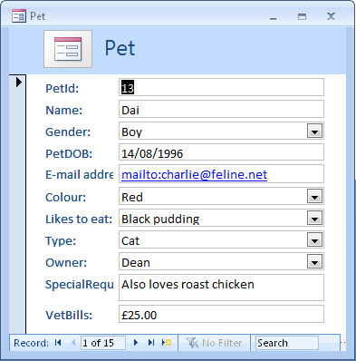
The form tool does all the hard work!

Step 2: Close the form, saving it with the name Basic Pet Details.
You can grab the template answer of the file to see the answers to this exercise, although please remember this is for you to check and confirm your attempted exercise only.

Exercise 2)
Step 1: Using the Pets Database in the previous exercise:
Create a report based on the Pet table using the Report Wizard as follows:

- Fields to include - PetName, Gender, PetDOB, VetBills
- Grouping - Gender
- Sorting - PetName (ascending)
- Summary - Average VetBills
- Layout - Landscape, Stepped
- Style - Office
- Title - Average Pet Costs By Gender

Your report should resemble the example shown below:

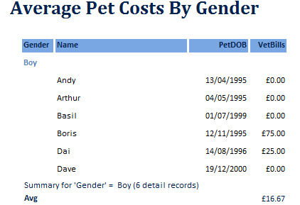
Feel free to make design changes to the report after you have created it

Step 2: Close the report and save it with the name AverageCostByGender
You can grab the template answer of the file to see the answers to this exercise, although please remember this is for you to check and confirm your attempted exercise only.

