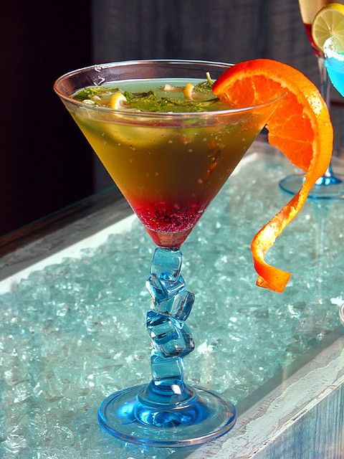

Photo By Kirti Poddar

Cocktail Demonstration and Party
Enjoy a Cocktail and a Mocktail. Make a Cocktail yourself and Play Games.
Join us at 12:30pm - 2:00pm in Whitireia Restaurant
(4th Floor) on 20th of March (Wednesday).
Price: $9.99/Advanced booking discount, $12/ door sales (Student ID is required)
Contact: Lika 021-02652500 Alice 022-1356087
Amanpreet 021-08215887 Rajesh -22-1767328
Condition: We can’t serve liquor under 18 years old

