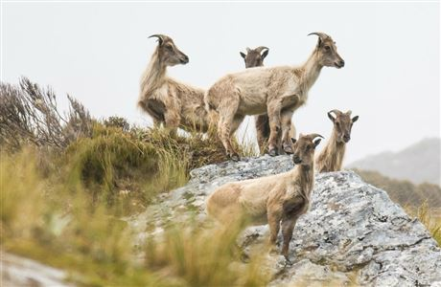
Bachelor of Information Technology
Systems Analysis and Design IT6501
Assignment 2 Part B

Due date and time Friday 7 October 2022 9 pm

Submission details
Upload your document into the Assignment 2 Part B dropbox in Moodle.

Extensions
Extensions of time will be granted for students who have an acceptable documented reason for not completing the assessment by the specified due date.

Terms
An attempt to pass this assessment must be made in order that the student will be eligible to sit the final exam for this module.

Grading
This assignment is worth 15% of the total module.
The assignment will be marked out of 15.

Deliverables
Produce a partial system specification report. This report is for an app for a smartphone to support the needs of the business described in the case study – PredatorFree T222. Include the following information in your report.
- An executive summary explaining the contents of the report (one paragraph).

- A class diagram for the app. Show the:
  - Classes
  - Associations between classes
  - Multiplicity
  - Class attributes
  - Operations (methods) – operation arguments are not required
  - Visibility on all attributes and operations
  - Describe the purpose of a class diagram (1 sentence). Put this above the diagram.
  - Describe your model in 2 or 3 sentences. Put this explanation above the diagram.
  - Put an automated caption on the figure and give the figure a meaningful caption using MSWord References | Insert Caption. Refer to your figure in the text (e.g. See Figure 4).
Note: Advanced notation such as generalisation-specialisation hierarchies and whole-part relationships are not required but if you want to use them that is acceptable.
- An activity diagram for the app showing the interactions between the key stakeholders and the app, from initial login to acceptance of the report. Describe the purpose of an activity diagram (1 sentence). Describe your model in 2 or 3 sentences. Put an automated caption on the figure and give the figure a meaningful caption. Refer to your figure in the text (e.g., See Figure 11). Position the diagram after the text. You can use swimlanes but they are optional.

- Select ONE specific system development methodology for your app and explain why it is appropriate for this project (1/2 page only). Assume the project will be completed within the development unit of the IT section and seven people are available to carry out the work who have skills in analysis and design, programming, testing, database design, and mobile user interface design. Include any assumptions you make about the level of experience and training the team already has on your chosen methodology.
Notes
- The functional and non-functional requirements of the server network and its administration systems are outside the scope of this assignment.
- The report must be to business standard, with appropriate fonts and font size (a bit like this assignment description).
- This assignment is carried out individually, not in groups.
- Produce all UML models using Visual Paradigm. You are strongly advised to create initial sketches on paper before proceeding to use the diagramming tool.

Marking Schedule

The marking schedule for this assignment is shown in Table 1. This is an example of a table with an automated caption inserted.

Table 1 This is the marking schedule for assignment 2 Part B
 | Requirements
1 | Executive summary
2 | Class model
3 | Activity model
4 | Methodology and justification
 | Quality evaluation requirements | Grading
- All requirements are present in the report (1-4).  - The introductory section is accurate and clearly written.  - The whole report is written clearly and describes each section appropriately in a sentence or two. The report must be to business-standard.  - Models show correct notation and naming conventions and have a title.  - Consistency between models in terms of names and relationships.  - The modelling tool is used correctly.  - Each table and figure (model or diagram) in the report includes a brief description of its purpose, and explanation, and a reference to the figure in the text.  - Quality of the document is excellent and includes page numbers, correct English spelling and grammar, appropriate fonts, layout, and headings. Figures and tables have appropriate captions. |  | 13-15 marks  All requirements are present in the report.  All quality evaluation requirements are met in full with very minor errors.  10-12 marks  Almost all requirements are present in the report. Quality evaluation requirements met but with some errors and omissions or one major omission.  7-9 marks  Some requirements are present in the report. Quality evaluation requirements not met in full. There are multiple errors and omissions or more than one major omission.  4-6 marks  The sections of the model are not explained properly and the models are incorrect and or inconsistent. There are multiple errors and omissions.  0-3 marks  Requirements not met. Quality evaluation requirements not met. The report has multiple errors and omissions.
Total |  | 15

